1. Select employee_id, hire_date, job_id, department_id

FROM employees

UNION

Select employee_id, TO_DATE(NULL), job_id, department_id

FROM job_history ORDER BY employee_id;

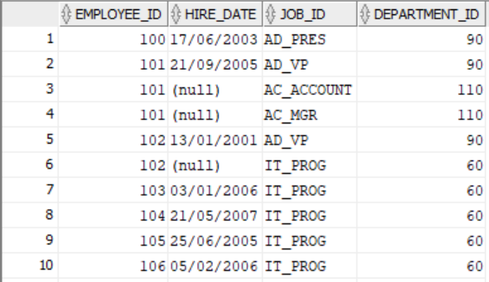

1. Select country_id, country_name from countries

WHERE country_id NOT IN (Select COUNTRY_ID from LOCATIONS

WHERE location_id IN

(Select location_id FROM departments INTERSECT

Select location_id FROM LOCATIONS));

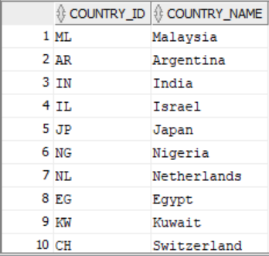

1. Select employee_id, job_id FROM EMPLOYEES

INTERSECT

Select employee_id, job_id FROM job_history;

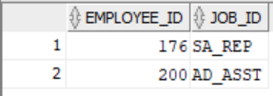

1. Select job_id, department_id from employees UNION

Select TO_CHAR(NULL), department_id from departments

WHERE department_id = 80 AND department_id = 50

ORDER BY department_id;

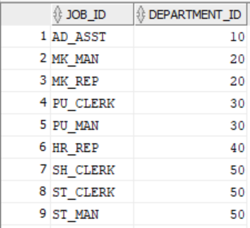

1. Select last_name, department_id, TO_CHAR(NULL) "department_name"

from employees

UNION

Select TO_CHAR(NULL), department_id, department_name

from departments;

